Task 6:
Setting up two breakpoints and clicking f5 to start debugging.
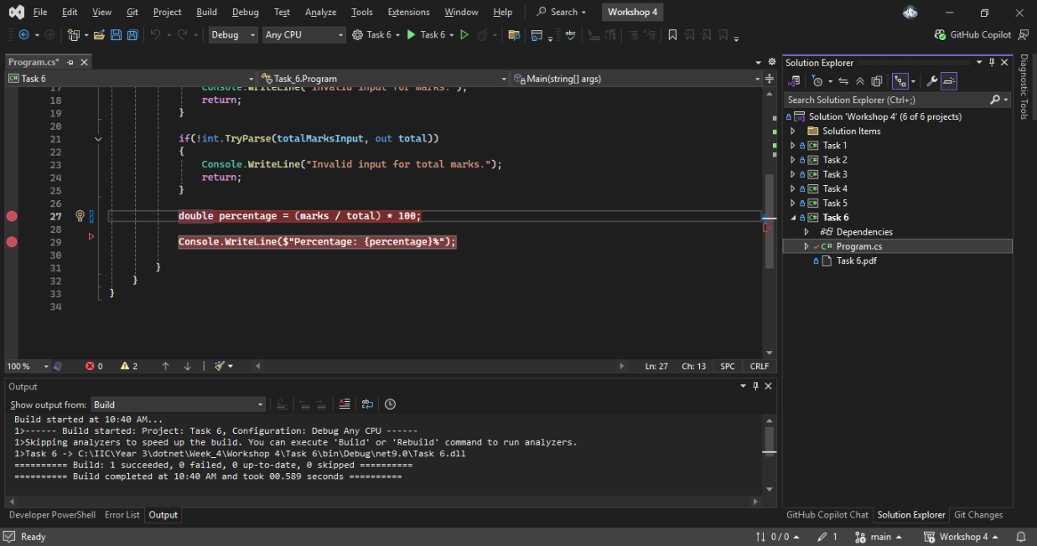

Entering values
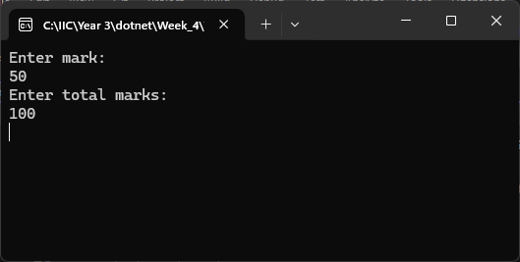
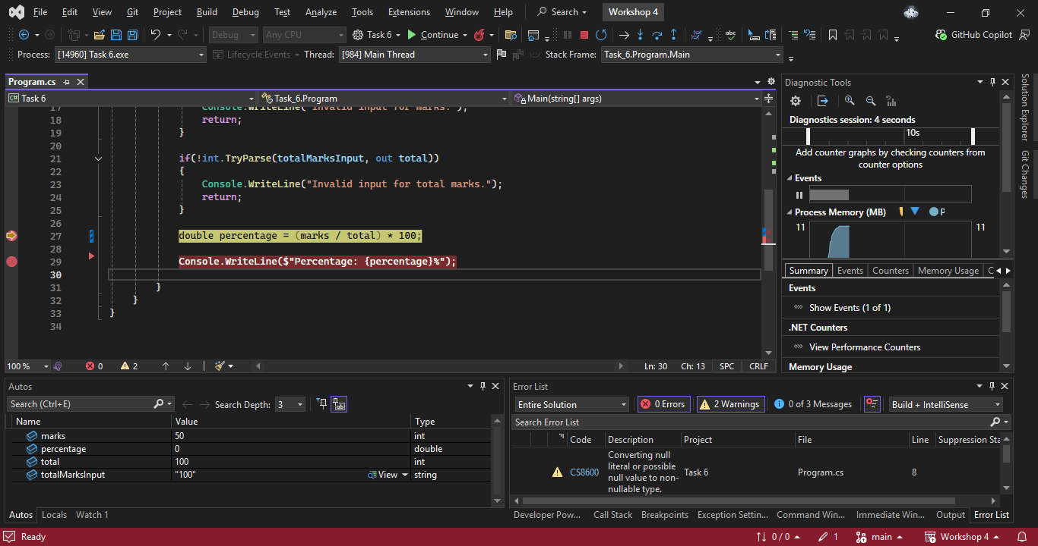

Observing the value:
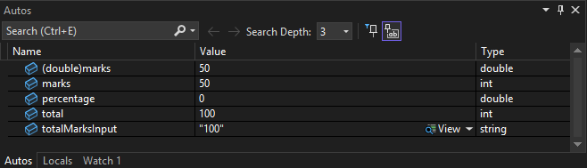

After that, I clicked on F10 to execute next line.
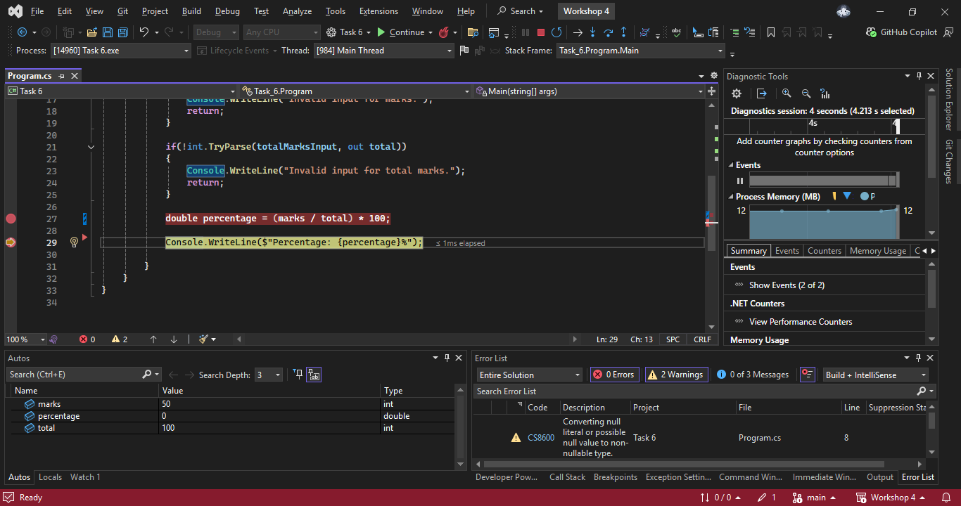
After executing all lines, I checked the output values but the output was 0% which is wrong.
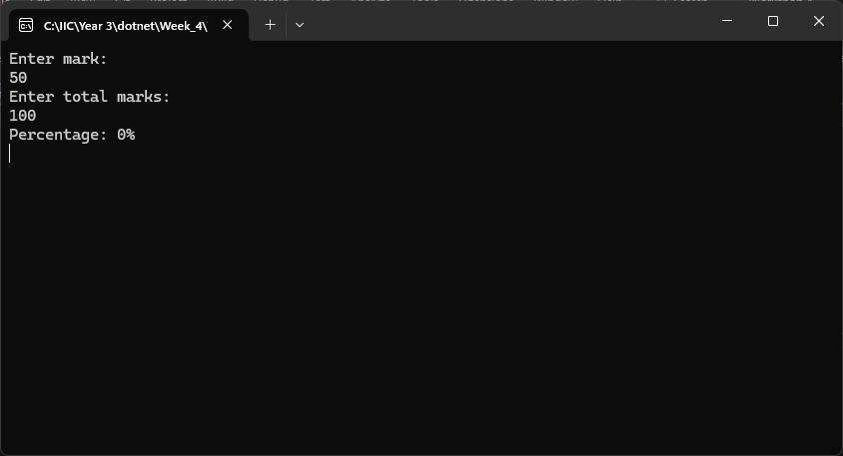

- Why is the output incorrect?
- It was wrong because both inputs were on integer. So the calculation was done in integer too. C# performs calculation of integer division as it is which will remove any decimal values. So we got 0 as output.

- How can we correct the program?
- We can correct the program by doing decimal calculations instead of just integer division.
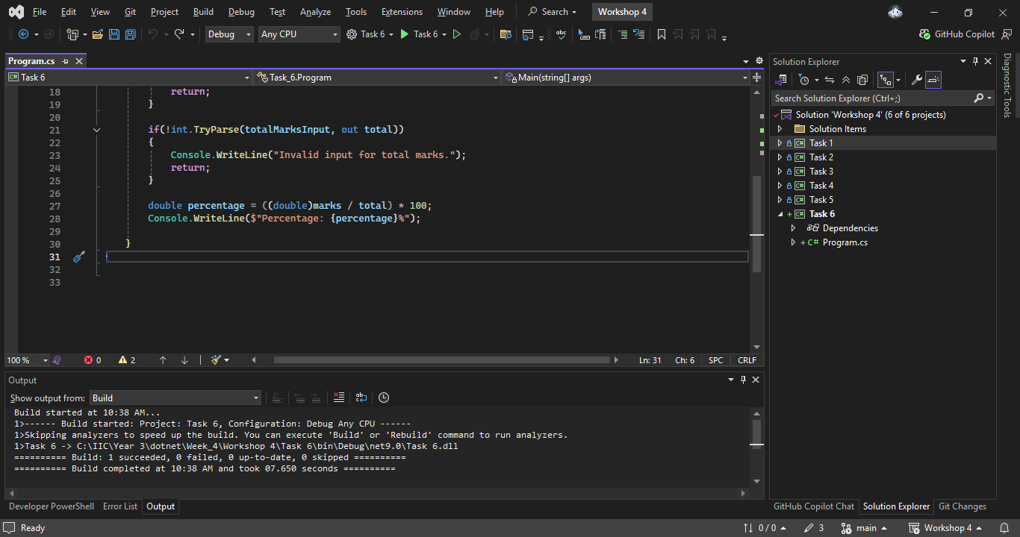

Correct answer:
